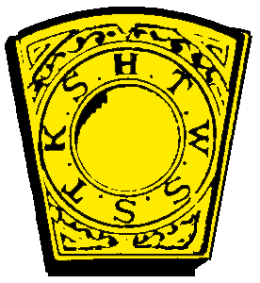
CERTIFICATE OF DEMIT

Chapter No. R.A.M.
, Oregon, , 2024
To Whom It May Concern:
This is to Certify, that Companion
whose signature is written in the margin hereof, is a Royal Arch Mason, and being in good standing of the aforementioned Chapter, under the jurisdiction of the Grand Chapter of Royal Arch Masons of Oregon, and having paid all demands against him, was thus permitted to withdraw from membership of said Chapter.
In Testimony Whereof, witness our sign manuals as High Priest and Secretary, and the Seal of said Chapter affixed and the date first above written.

High Priest

Secretary

If this Demit is to be used outside of Oregon, this blank must be filled, as required by other Jurisdictions.

This is to Certify, that
is a regular Chapter under the Jurisdiction of the Grand Chapter of Royal Arch Masons of Oregon.

Grand Secretary

CHAPTER RECORD DATES

