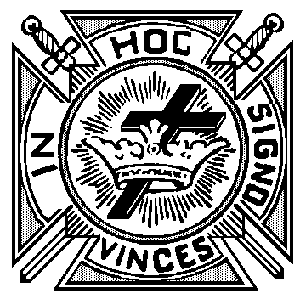
Application
Life Membership K.T.

, 20
From:

Commandery No.

, Oregon

To: Michael D. Sullivan
Grand Recorder
PO Box 418
Coos Bay, OR 97420

Sir Knight Sullivan,

Enclosed find check in amount of $ in payment of the Life Membership in this
Commandery for, plus $ 2.50 , the fee for a Certificate for:

Sir Knight
Address

He was born
Date

At
and Received the Orders of Knighthood in Commandery No.
located at
on the following dates:
Red Cross:
Malta:
Temple:
{
Commandery
Knight
Please mail Life Certificate to:
(Circle One)
MESSAGE

Courteously yours,
, Recorder

