 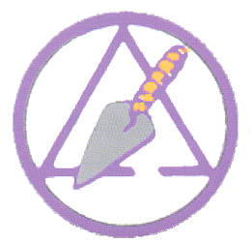 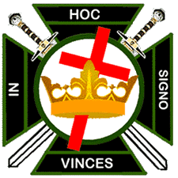

Arago Chapter #22 Occidental Council #12 Pacific Commandery #10

Royal Arch Masons Cryptic Masons Knights Templar

10/10/2024

Companion and/or Sir Knight,

I bring you greetings from the Bay Area York Rite. This letter serves as notice of Election of Officers for 2025 in Arago Chapter #22 and Occidental Council #12. They will take place in Reedsport on Monday evening Nov. 4th, 2024 at 7:00pm. On the next page, you will find your dues renewal. If you have not, and would like to, purchase a Life Membership you may do so. Please see the chart below for prices. If you owe back dues, you must add this to the Life Membership fees so you will become current. Hope you all have a Safe and Happy Holiday Season!!!

Fraternally,

Michael D. Sullivan, Secretary/Recorder

Bay Area York Rite Bodies

60 Cypress Point, Coos Bay, OR 97420

541-404-6261

[oregonbayareayorkrite@gmail.com](mailto:oregonbayareayorkrite@gmail.com)

Arago Chapter #22 Life Membership – Payable to Arago Chapter #22

Age 21-35 ($252.50) Age 36-50 ($152.50) Age 51+ ($102.50)

Occidental Council #12 Life Membership – Payable to Occidental Council #12

Age 21-35 ($302.50) Age 36-50 ($252.50) Age 51-65 ($202.50) 66+ ($152.50)

50 Year Member ($52.50)

Pacific Commandery #10 Life Membership – Payable to Pacific Commandery #10

All Ages ($402.50)

**DUES FOR THE YEAR 2025:**

**Arago Chapter Royal Arch Masons: $________________**

**Occidental Council Cryptic Masons: $________________**

**Pacific Commandery Knights Templar $________________**

**Unpaid Dues: Year(s) ________________ $________________**

**TOTAL $________________**

**VOLUNTARY CONTRIBUTION TO THE FOLLOWING CHARITY(S) $________________**

**Please Circle: RARA; Dodge Fund; CMMRF; KT Eye foundation**

For dues renewal mail one check.

Payment to:  **Pacific Commandery #10**

**60 Cypress Point**

**Coos Bay, OR 97420**