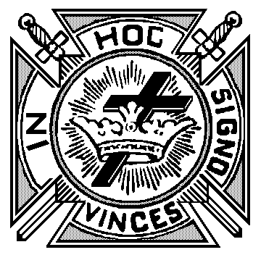 Application

Life Membership K.T.

      , 20

From:

      Commandery No.

      , Oregon

To: Michael D. Sullivan

Grand Recorder

P.O. Box 12

Coos Bay, OR 97420

Sir Knight Sullivan,

Enclosed find check in amount of $       in payment of the Life Membership in this

Commandery for, plus $ 2.50 , the fee for a Certificate for:

Sir Knight

Address

He was born

Date

At

and Received the Orders of Knighthood in       Commandery No.

located at

on the following dates:

Red Cross:

Malta:

Temple:

{

Commandery

Knight

Please mail Life Certificate to:

MESSAGE

(Circle One)

Courteously yours,

, Recorder